**NAGARJUNA COLLEGE OF ENGINEERING AND TECHNOLOGY (An Autonomous College under VTU)**

**Venkatagiri Kote post, Devanahalli, Bengaluru-562164**

**Department of Computer Science and Engineering**

**&**

**Department of Artificial Intelligence and Machine Learning**



**ADVANCED JAVA PROGRAMMING**

**LABORATORY MANUAL**

21CSL55

**Prepared By:**

|  |  |
| --- | --- |
| **Prof. KOUSHIKA K H** |  |
|  |

**Department Vision and Mission statements**

**VISION**

Excellence in creating globally competent professionals and leaders in the field of Computer Science & Engineering.

**MISSION**

**M1:** Creating Excellence in Computer Science & Engineering education through academic professionalism, teaching, curricula which reflect the changing needs of the society.

**M2:** Establishing center of excellence by creating knowledge through research and industrial exposure in the area of Computer Science & Engineering.

**M3:** Developing communication skill, leadership qualities, teamwork & skills for continuing education among the students.

**M4:** Inculcating ethics, human values and skills for solving societal problems and environmental protection.

**M5:** Validate engineering knowledge through innovative research projects to enhance their employability and entrepreneurship skills.

**ADVANCED JAVA PROGRAMMING LABORATORY**

|  |  |  |  |  |  |
| --- | --- | --- | --- | --- | --- |
| **Course code** | **L:T:P:S** | **Credits** | **Exam Marks** | **Exam Duration** | **Course Types** |
| **21CSL55** | **0:0:2:0** | **01** | **CIE:50 SEE:50** | **03 Hours** | **PCC** |

**Course Objectives:**

## The Student will:

## Understand and manipulate Java strings effectively.

## Master the usage of Array Lists for dynamic data storage.

## Gain proficiency in connecting Java applications to databases.

## Understand and implement the Iterator class for efficient data traversal.

## Learn to handle byte array input efficiently in Java.

## Programs List

|  |  |
| --- | --- |
| **Sl. No.** | **Programs** |
| 1 | Write a Java program to sort array of strings using CompareTo function. |
| 2 | Write a Java program to count the occurrence of character in a given string using suitable String handling functions. |
| 3 | Write a program to perform string operations using Array List. Write functions for the following  a. Append - add at end b. Insert - add at particular index c. Search d. List all string starts with given letter. |
| 4 | Write a java program to Create an ArrayList of type String and prompt that user for three names and add these names to your ArrayList.  b) Print a message with the number of elements in the ArrayList for the user using the size method.  c) Prompt the user for two more names and add them to the ArrayList and once again print a message with the number of elements in the ArrayList for the user.  d) Use a loop to print all of the names in the ArrayList for the user.  e) Ask the user for a name to remove, remove the value the user provides, and then use an enhanced for loop to print all of the names in the ArrayList for the user. |
| 5 | Write a Java program to add elements to the start of a list and to add elements to the end of the list. Obtain the first and last element. Remove first and last element. |
| 6 | Write a java program to implement both the Iterator and ListIterator interfaces. |
| 7 | Create a program to reads the data from two files and writes in to another file and to display only files in a specified location. |
| 8 | Write a Java program to read and write string using ByteArray Input and  Output stream. |
| 9 | Create a Java Program to implement swing-based applets. |
| 10 | Create a Java Program to handle the event generated by a Swing push button. |
| 11 | Create an application to retrieve information (author id, name, address, city, and state) about the authors who are living in the city where the city name begins with letter "B". You need to write the code to perform the following tasks in the application:  1. Loading a driver.  2. Connect to the Database.  3. Create and execute JDBC statements.  4. Display the result. |
| 12 | Create an application to retrieve details of all the authors living in a city |

**Course outcomes:**

The student will be able to:

**CO1:** Students will master advanced string manipulation techniques in Java, including substring extraction, concatenation, formatting, and regular expressions.

**CO2:** Students will demonstrate the effective use of Array Lists in Java, understanding dynamic resizing, adding, removing, and iterating through elements.

**CO3:** Students will be proficient in connecting Java applications to databases using JDBC, performing

CRUD operations and handling exceptions related to database connectivity.

**CO4:** Students will learn to efficiently handle byte array input in Java, including reading and writing data from/to streams, such as File Input Stream and Byte Array Output Stream.

**CO5:** Students will understand and implement the Iterator class for traversing various data structures,

including Array Lists, efficiently and effectively.

1. Write a Java program to sort array of strings using CompareTo function**.**

**PROGRAM**

public class StringArraySort {

public static void main(String[] args) {

// Sample array of strings

String[] stringArray = {"Banana", "Apple", "Orange", "Grape", "Kiwi"};

// Sorting the array using compareTo() function

for (int i = 0; i < stringArray.length - 1; i++) {

for (int j = i + 1; j < stringArray.length; j++) {

if (stringArray[i].compareTo(stringArray[j]) > 0) {

// Swap if the current element is greater than the next

String temp = stringArray[i];

stringArray[i] = stringArray[j];

stringArray[j] = temp;

}

}

}

// Displaying the sorted array

System.out.println("Sorted String Array: " + Arrays.toString(stringArray));

}

}

**OUTPUT:**



**2)** Write a Java program to count the occurrence of character in a given string using suitable String handling functions.

**PROGRAM**

import java.util.Scanner;

public class CharacterOccurrenceCounter {

public static void main(String[] args) {

Scanner scanner = new Scanner(System.in);

// Input the string

System.out.print("Enter a string: ");

String inputString = scanner.nextLine();

// Input the character to count

System.out.print("Enter the character to count: ");

char targetCharacter = scanner.next().charAt(0);

// Count occurrences using string handling functions

int count = countOccurrences(inputString, targetCharacter);

// Display the result

System.out.println("Occurrences of '" + targetCharacter + "' in the string: " + count);

}

private static int countOccurrences(String inputString, char targetCharacter) {

int count = 0;

for (char c : inputString.toCharArray()) {

if (c == targetCharacter) {

count++;

}

}

return count;

}

}

**OUTPUT:**

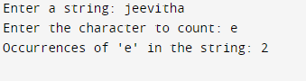

3)Write a program to perform string operations using Array List. Write functions for the following. a. Append - add at end b. Insert - add at particular index c. Search d. List all string starts with given letter.

a. Append - add at end b. Insert - add at particular index c. Search d. List all string starts with given letter.

**PROGRAM**

import java.util.*;

public class ArrayL

{

ArrayList<String> list=new ArrayList<String>(); //Creating arraylist

public void arraydisplay()

{

list.add("CSE");//Adding object in arraylist

list.add("ISE");

list.add("ME");

System.out.println("ArrayList element are");

System.out.println(list);

System.out.println("");

}

public void appendatend()

{

System.out.println("Enter the element to append at end");

Scanner scob1=new Scanner(System.in);

String ele=scob1.next();

list.add(ele);

System.out.println(list);

System.out.println("");

}

public void insertatpos()

{

System.out.println("Enter the position and element to insert");

Scanner scob1=new Scanner(System.in);

int posind=scob1.nextInt();

String ele=scob1.next();

list.add(posind,ele);

System.out.println(list);

System.out.println("");

}

public void searchele()

{

System.out.println("Enter the Array element to search");

Scanner scobj=new Scanner(System.in);

String arele=scobj.next();

int in=list.indexOf(arele);

if(in==-1)

{

System.out.println("Element not found");

}

else

{

System.out.println("Element found at "+in);

}

}

void print()

{

System.out.println("Enter the starting charecter to print strings");

Scanner nip=new Scanner(System.in);

char inputc=nip.next().charAt(0);

String strc=Character.toString(inputc);

System.out.println("String starting with character "+strc);

for(int i=0;i<list.size();i++)

{

if(list.get(i).startsWith(strc))

{

System.out.println(list.get(i));

}

}

}

public static void main(String args[])

{

ArrayL obj=new ArrayL();

obj.arraydisplay();

obj.appendatend();

obj.insertatpos();

obj.searchele();

obj.print();

}

}

**OUTPUT:**

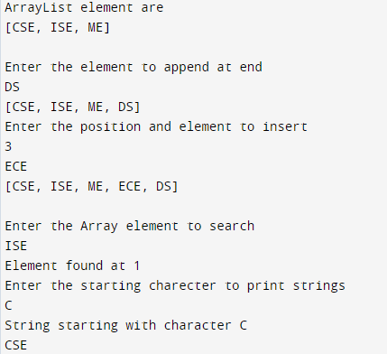

**4)** **Create an ArrayList of type String and prompt that user for three names and add these names to your ArrayList.**

**b) Print a message with the number of elements in the ArrayList for the user using the size method.**

**c) Prompt the user for two more names and add them to the ArrayList and once again print a message with the number of elements in the ArrayList for the user.**

**d) Use a loop to print all of the names in the ArrayList for the user.**

**e) Ask the user for a name to remove, remove the value the user provides, and then use an enhanced for loop to print all of the names in the ArrayList for the user.**

**PROGRAM**

import java.util.ArrayList;

import java.util.Scanner;

public class ArrayListExample {

public static void main(String[] args) {

// Create an ArrayList of type String

ArrayList<String> namesList = new ArrayList<>();

// Prompt the user for three names and add them to the ArrayList

Scanner scanner = new Scanner(System.in);

for (int i = 1; i <= 3; i++) {

System.out.print("Enter name " + i + ": ");

String name = scanner.nextLine();

namesList.add(name);

}

// Print the number of elements in the ArrayList

System.out.println("Number of elements in the ArrayList: " + namesList.size());

// Prompt the user for two more names and add them to the ArrayList

for (int i = 4; i <= 5; i++) {

System.out.print("Enter name " + i + ": ");

String name = scanner.nextLine();

namesList.add(name);

}

// Print the number of elements in the updated ArrayList

System.out.println("Number of elements in the updated ArrayList: " + namesList.size());

// Use a loop to print all of the names in the ArrayList

System.out.println("Names in the ArrayList:");

for (String name : namesList) {

System.out.println(name);

}

// Ask the user for a name to remove

System.out.print("Enter a name to remove: ");

String nameToRemove = scanner.nextLine();

// Remove the name provided by the user

namesList.remove(nameToRemove);

// Use an enhanced for loop to print all of the names in the updated ArrayList

System.out.println("Names in the updated ArrayList:");

for (String name : namesList) {

System.out.println(name);

}

// Close the scanner

scanner.close();

}

}

**OUTPUT:**

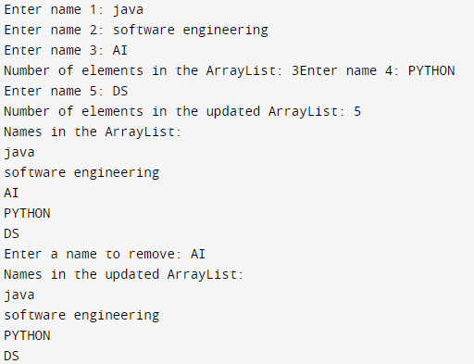

**5)** Write a Java program to add elements to the start of a list and to add elements to the end of the list. Obtain the first and last element. Remove first and last element.

**PROGRAM**

import java.util.ArrayList;

import java.util.List;

public class ListManipulation {

public static void main(String[] args) {

// Creating a List

List<String> myList = new ArrayList<>();

// Adding elements to the start of the list

myList.add(0, "Element1");

myList.add(0, "Element2");

// Adding elements to the end of the list

myList.add("Element3");

myList.add("Element4");

// Displaying the list before removal

System.out.println("List before removal: " + myList);

// Obtaining and removing the first element

String firstElement = myList.remove(0);

// Obtaining and removing the last element

String lastElement = myList.remove(myList.size() - 1);

// Displaying the list after removal

System.out.println("List after removal: " + myList);

// Displaying the first and last elements that were removed

System.out.println("First element removed: " + firstElement);

System.out.println("Last element removed: " + lastElement);

}

}

**OUTPUT:**

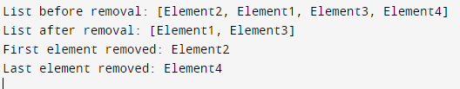

6) Write a java program to implement both the Iterator and ListIterator interfaces.

**PROGRAM**

import java.util.ArrayList;

import java.util.Iterator;

import java.util.List;

import java.util.ListIterator;

public class IteratorExample {

public static void main(String[] args) {

List<Integer> numbers = new ArrayList<>();

numbers.add(1);

numbers.add(2);

numbers.add(3);

numbers.add(4);

// Using Iterator

System.out.println("Using Iterator:");

Iterator<Integer> iterator = numbers.iterator();

while (iterator.hasNext()) {

System.out.println(iterator.next());

}

// Using ListIterator

System.out.println("\nUsing ListIterator (forward):");

ListIterator<Integer> listIterator = numbers.listIterator();

while (listIterator.hasNext()) {

System.out.println(listIterator.next());

}

// Using ListIterator in reverse

System.out.println("\nUsing ListIterator (backward):");

while (listIterator.hasPrevious()) {

System.out.println(listIterator.previous());

}

}

}

**OUTPUT:**

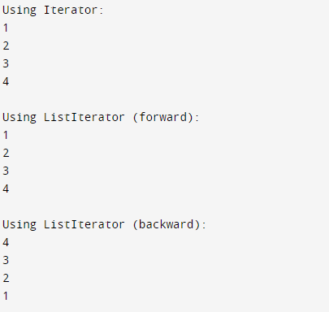

7)Create a program to reads the data from two files and writes in to another file and to display only files in a specified location.

**PROGRAM**

import java.io.BufferedReader;

import java.io.BufferedWriter;

import java.io.FileReader;

import java.io.FileWriter;

import java.io.IOException;

public class MergeFilesAndDisplay {

public static void main(String[] args) {

// Specify the paths of the two input files

String inputFile1 = "C:\Users\Admin\Desktop\input1.txt";

String inputFile2 = "C:\Users\Admin\Desktop\input2.txt";

// Specify the path of the output file

String outputFile = "C:\Users\Admin\Desktop\output.txt";

{

// Read data from the first file

BufferedReader reader1 = new BufferedReader(new FileReader(inputFile1));

String data1 = "";

String line1;

while ((line1 = reader1.readLine()) != null) {

data1 += line1 + "\n";

}

reader1.close();

// Read data from the second file

BufferedReader reader2 = new BufferedReader(new FileReader(inputFile2));

String data2 = "";

String line2;

while ((line2 = reader2.readLine()) != null) {

data2 += line2 + "\n";

}

reader2.close();

// Merge data from both files

String mergedData = data1 + data2;

// Write the merged data into the output file

BufferedWriter writer = new BufferedWriter(new FileWriter(outputFile));

writer.write(mergedData);

writer.close();

System.out.println("Merged data written to " + outputFile);

// Display the contents of the output file

System.out.println("Contents of the merged file:");

BufferedReader mergedReader = new BufferedReader(new FileReader(outputFile));

String line;

while ((line = mergedReader.readLine()) != null) {

System.out.println(line);

}

mergedReader.close();

} catch (IOException e) {

e.printStackTrace();

}

}

}

**OUTPUT:**

**OUTPUT:**

**OUTPUT:**

**OUTPUT:**